A Unified Stacked Framework for Energy–Geometry–Time Integration in Curvature Synchronization Theory

Abstract
This work presents a unified stacked framework that connects mass–energy equivalence, stress–energy structure, spacetime curvature, temporal measurement, and synchronization-based control into a coherent system for relativistic navigation. The framework is constructed as a layered architecture in which each level produces the inputs required by the next. While the governing equations of spacetime curvature are well established through general relativity, the physical generation and control of the required stress–energy distributions remain beyond current technological capabilities. As such, large-scale spacetime manipulation, including warp engines and spacetime jumping, remains theoretical. The framework instead provides a complete structure for measurement, synchronization, and trajectory optimization within spacetime, forming a foundational control architecture for future propulsion systems.

Integrated Stack: Equation-by-Equation Flow
The framework is not a single equation. It is a stacked sequence of physical processes, where each equation performs a specific role and feeds the next.

Layer 1 — Energy Scale
$$E=mc^{2}$$
Energy is derived from mass. This defines the total available energy budget.
This layer answers:
- How much energy is available
- What is the maximum possible influence on spacetime

Layer 2 — Energy Density (Bounded Region)
$$ρ=\frac{E}{V}$$
Energy is distributed over a finite region of volume $V$.
This introduces the box–circle interpretation:
- The box defines the bounded energy region
- The circle represents the internal curvature region
This layer determines:
- How concentrated energy is
- Whether curvature effects are significant

Layer 3 — Stress–Energy Structure
$$T_{μν}$$
Energy must be structured, not just present.
$$T_{μν}=\left[\begin{matrix}\text{energy density} & \text{momentum flow} \\ \text{momentum flow} & \text{pressure / tension}\end{matrix}\right]$$
This layer defines:
- Direction of energy flow
- Compression vs tension
- Spatial distribution
This is the true physical source of curvature.

Layer 4 — Spacetime Curvature (Einstein Field Equation)
$$G_{μν}+Λg_{μν}=\frac{8πG}{c^{4}}T_{μν}$$
This equation defines how energy structure produces spacetime curvature.
Output:
- Metric $g_{μν}$
- Geometry of spacetime

Layer 5 — Proper Time (Motion Through Spacetime)
$$dτ^{2}=-g_{μν}dx^{μ}dx^{ν}$$
This defines how time flows along a path.
This layer includes:
- Time dilation
- Gravitational effects
- Path-dependent time

Layer 6 — Clock Measurements (Physical Data Layer)
$$T_{i}=\int_{γ_{i}}{dτ}$$
Time is measured along trajectories.
$$\left\{T_{i}\}=\{T_{\text{atomic}},T_{\text{UTC}},T_{\text{interstellar}}\right\}$$
This includes:
- Atomic clocks
- UTC reference
- Interstellar timing (Voyager 1 & 2)
This layer produces real measurable data.

Layer 7 — Time Difference (Synchronization Signal)
$$ΔT_{i}=T_{i}-T_{\text{ref}}$$
This defines the difference between clocks.
This encodes:
- Distance (signal delay)
- Velocity effects
- Gravitational differences

Layer 8 — CST Optimization
$$C_{\text{CST}}=\sum_{i}{w_{i}}(T_{i}-T_{\text{ref}})^{2} \\ C_{\text{CST}}→min⁡$$
This defines the system objective:
Minimize timing mismatch.

Layer 9 — Control and Navigation
$$a_{\text{control}}^{μ}∝-∇^{μ}C_{\text{CST}}$$
This layer produces physical action:
- Trajectory adjustment
- Thrust timing
- Navigation correction

Stack Interpretation
The system operates as a sequential chain:
Energy → Density → Structure → Curvature → Time → Measurement → Synchronization → Control
Each layer performs a distinct physical role. The equations do not combine into a single expression because they represent different domains of physics.

Engineering Gap: Missing Physical Layer
The framework is mathematically complete but physically incomplete at one critical point:
$$\text{engine or field system}→T_{μν}^{required}$$
While the inverse Einstein equation defines the required stress–energy:
$$T_{μν}^{required}=\frac{c^{4}}{8πG}\left(G_{μν}[g_{target}]+Λg_{μν}^{target}\right)$$
there is currently:
- no rocket
- no propulsion system
- no field generator
capable of producing or controlling such distributions.

Physical Constraints

Unrealized Stress–Energy Conditions
- Negative energy density
- Extreme الضغط/tension
- Exotic matter

Energy Scale Limitation
$$E=mc^{2}$$
Even small curvature requires extremely large energy.

Structural Complexity
$$T_{μν}=\text{energy density + momentum + pressure + tension}$$
The challenge is not energy alone, but structure.

Relation to Warp and Jump Concepts
- Warp drive → continuous curvature control (theoretical)
- Wormhole jump → instantaneous connection (theoretical)
Both require stress–energy distributions beyond current technology.

Conclusion
The unified stacked framework successfully connects energy, spacetime geometry, temporal measurement, and control into a coherent and logically consistent system. Each layer of the stack performs a distinct role, forming a sequential chain that links mass–energy equivalence to navigation and control within spacetime. The Einstein field equation provides the governing relationship between stress–energy and curvature, and its inverse form defines the requirements for spacetime manipulation. However, the physical generation and control of the required stress–energy tensor remains unresolved. No existing propulsion system or rocket technology can produce or sustain the necessary energy distributions at the required scale. As a result, spacetime manipulation, warp engines, and spacetime jumping remain theoretical. The framework presented here does not attempt to generate curvature directly, but instead provides complete architecture for measurement, synchronization, and navigation within spacetime. It therefore represents a foundational control system for future propulsion technologies, should the engineering challenges of stress–energy generation be overcome.

References
Einstein, A. The Field Equations of Gravitation
Misner, C. W., Thorne, K. S., Wheeler, J. A. Gravitation
Arnowitt, R., Deser, S., Misner, C. The Dynamics of General Relativity
Alcubierre, M. The Warp Drive: Hyper-Fast Travel within General Relativity
Ashby, N. Relativity in the Global Positioning System

Stack Diagram (Layered Flow of the Unified Framework)
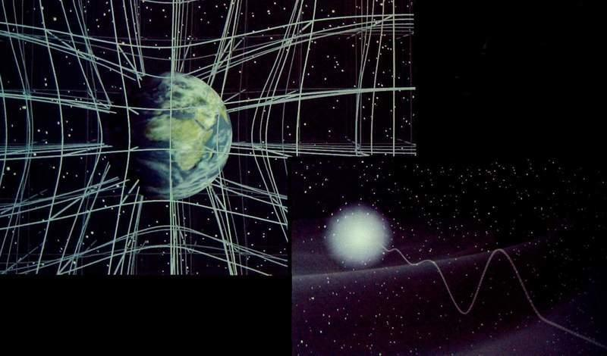

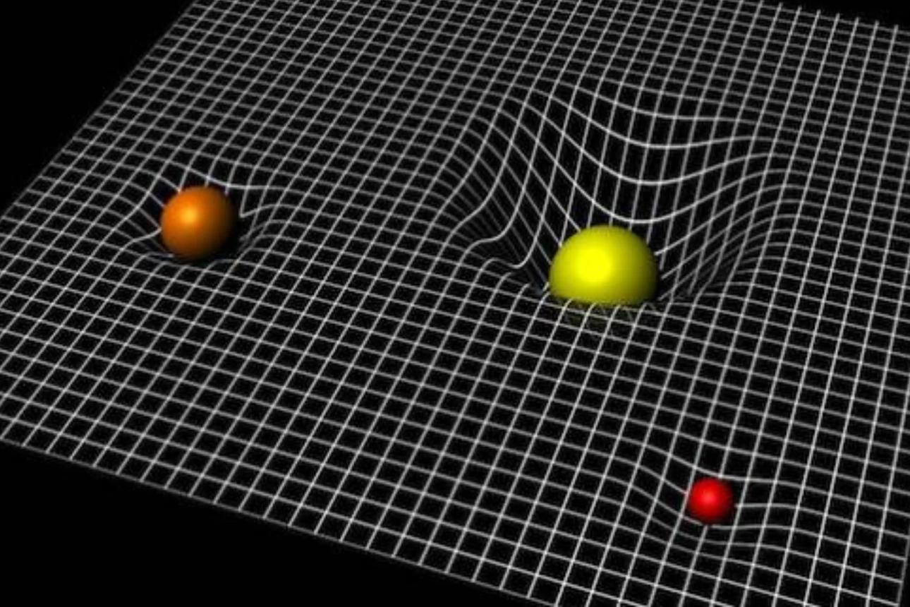
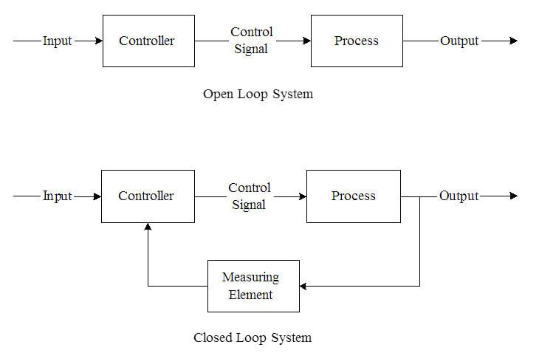

How to read the diagram
The diagram represents a vertical stack:
- Top → Energy (E = mc²)
- Downward flow → Density → Stress–Energy → Curvature → Time → Measurement → CST → Control
- Arrows → each layer feed the next
- Bottom → control actions (trajectory, thrust, timing)
It is not one equation—it is a chained system of equations.

